EASY START UP GUIDE
Rev 1
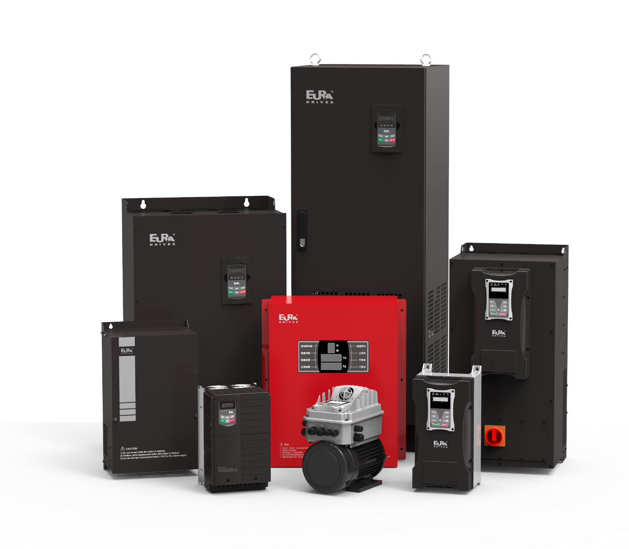

Setting up the Drive for Basic Operation
F647 – Set to English #1
F800 – Set up the Motor
F800 – Motor Tuning – after all the motor parameters have been entered set F800 to 1 for rotating tuning or 2 for stationary tuning
F801 – Rated power in kW
F802 – Rated Voltage
F803 – Rated current
F804 – Number of poles
F805 – RPM
F810 – Rated frequency

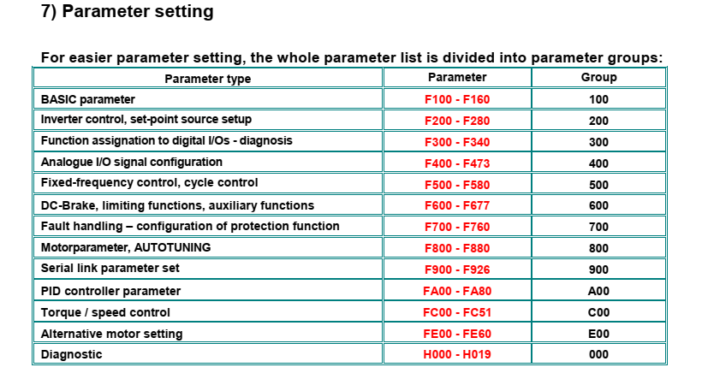
Parameter Group 100 - Basic parameters

F109 – Start frequency or minimum frequency 0-10Hz
F110 – Start frequency hold time – 0-10 seconds
F111 – Max Frequency – set to 60Hz
F112 – minimum frequency – usually set to 0
F113 – set to same as maximum frequency F111
F114 – Acceleration time – set to appropriate value
F115 – Deceleration time – set to appropriate value
F118 – Knee Frequency – should be 60Hz
F119 – Acceleration time set to max frequency so set to 1
F120 – Dead time during reversing – if reversing, a value set here will make the drive stop at 0Hz during a reversal for the amount of time set.
F122 – Reversing lock or prevention. Drive is enabled for FWD / REV out of the factory but can be locked to FWD only set to 1
F123 – leave at 0 if using the FWD / REV inputs but enable if providing a negative speed reference
F124 – Jog Frequency
F125 and F126 – accel / decel ramps for jog function
F127, 128, 129, 130 – skip frequency – typically used on fan applications
F131 – What is displayed on the pendant during operation – factory default of 15 which is frequency, speed in RPM, motor current, motor voltage and DC Bus voltage. Can be changed if desired – see manual.
F132 – display of pendant during stop – factory default of 6 which is frequency, RPM setpoint and DC Bus voltage. Can be changed if required see manual.
F137 – Voltage frequency characteristic for V/Hz mode only – linear (0) or quadratic (1), user defined (2), automatic (3) or defined by user selected setpoints (4)
If F137 = 2 then F140 thru F151 are the set frequencies and voltages
F138 – linear characteristic range 1-20 – leave as default
F139 – quadratic characteristic range 1-6 see chart on page 44
F153 – PWM Frequency – 800 – 16,000Hz (automatic carrier frequency available – F159)
F154 – Power supply voltage compensation – activate on non-critical speed applications as this function will stretch the deceleration ramp if the power supply fluctuates
F159 – random PWM modulation leave at default
F160 – Default parameter reset – 11 resets to US parameters

Parameter Group 200 – Inverter Control
F200 – Start command source – keypad only, terminal input only, both, modbus or all three – default is 4
F201 – Stop command source – same as start command – default is 4
F200-201 take their start/stop commands from pulse inputs. If a maintained input is being used then go to F208 for two/three wire control.
F202 – rotation direction – forward, reverse, controlled by static terminal signals (FWD/REV), remote keypad or remote keypad with power down memory. If using two/three wire control set to 2.
F203 – Primary speed reference source –
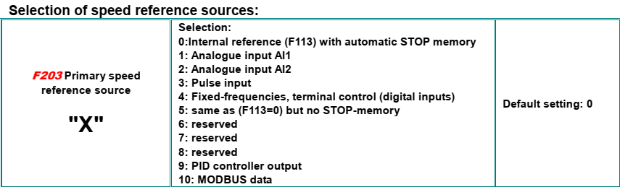
F204 – Secondary speed reference source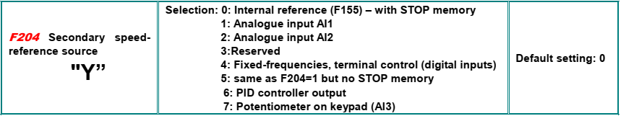
F208 – how the digital I/O operates – Recommend going with Two-wire Type 1 static (1) – See options in manual.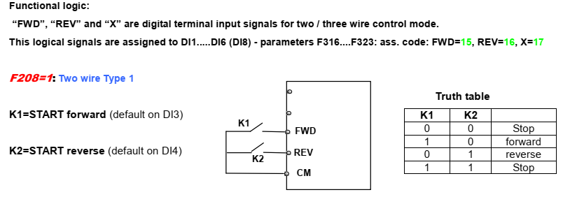
F209 – Stop mode selection – 0 ramp to stop, 1 – coast to stop, 2 – DC injection
F213 – Autostart after power-down – normally 0
F214 – Inverter Error Auto Reset – normally 0
F215 – Power-on autostart delay in seconds
F216 – Number of error-resets allowed
F217 – Delay time for error reset

Parameter Group 300 – Digital I/O

Multifunctional Input and Output Terminals
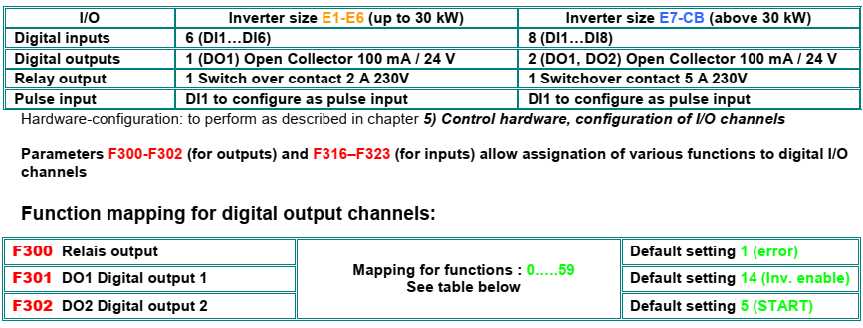

F300 – relay output – selection of how the output relay functions default is inverter fault protection
F301 – DO1 output – default is running
F302 – DO2 output – default is running
F303 – DO1 can do pulse output instead of maintained
F304, 305, 306 – setting up S-curve starting and stopping

Setting up the Digital Inputs for operation.

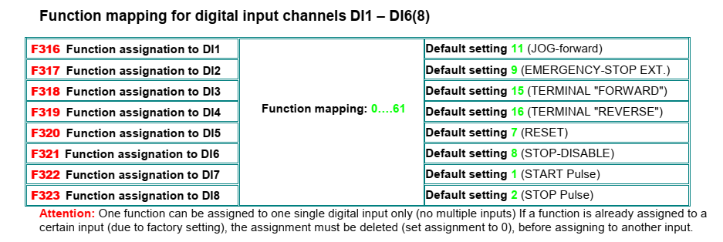

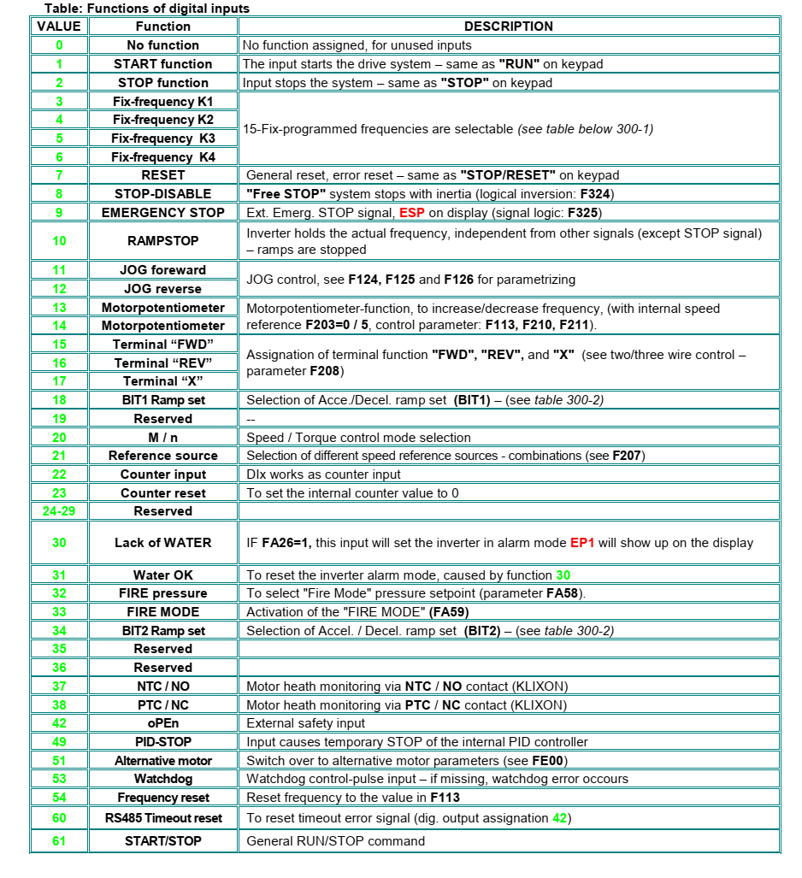
The digital I/O is configurable. Note the factory default settings above. Terminal “FWD” with a maintained input the drive will start and run. When the input is removed the drive will stop. Terminal “REV” will do the same as “FWD” but in the opposite rotation. Note – when the drive is in two or three wire control the operator panel does not function.

Parameter Group 400 is for setting up Analog I/O
Standard configuration is 0-10 V with 0-20mA or 4-20mA as an option.
Parameter Group 500 is for setting up the Fixed-Frequencies
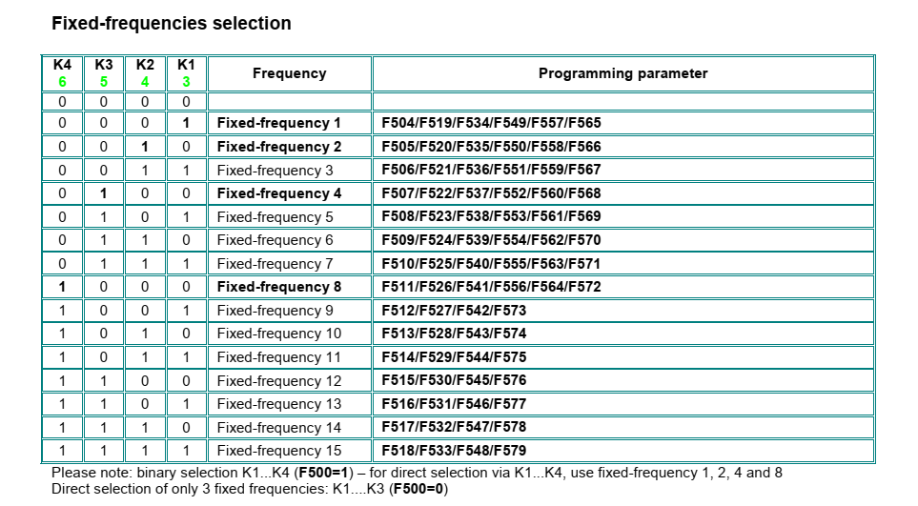
Parameter Group 600 is for DC Brake Control
Parameter Group 700 is for Error Handling and Protection Functions

